Augmented Reality with Planar Homographies

CMPT 412

Aditya Rajvanshi – 301349754

Disclaimer:

Late submission with first late day used

“book.mov” not included in the main zip file due to size constraint, so book.mov was zipped and submitted under “extra space if needed”.

Part 4.1: Feature Detection, Description, and Matching

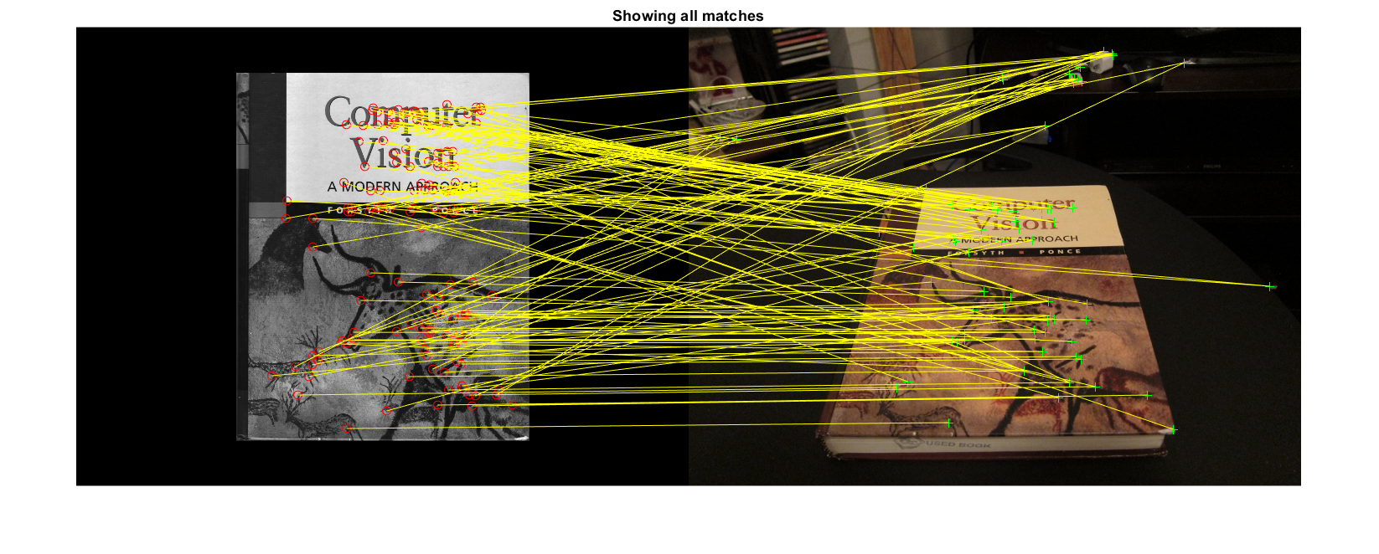

Part 4.2: BRIEF and Rotations

The graph on the left shows is the plot for SURF while the graph on the right is the plot for BRIEF. We see that SURF is more robust against rotations than BRIEF. This happens because SURF accounts for the orientation better than BRIEF does. BRIEF attempts to approximate the locations of matched features, whereas, the in-built SURF from MATLAB likely uses interpolation to calculate the positions of each matches. This is further evident in the examples provided on the next pages, where SURF has far more matches than BRIEF does.

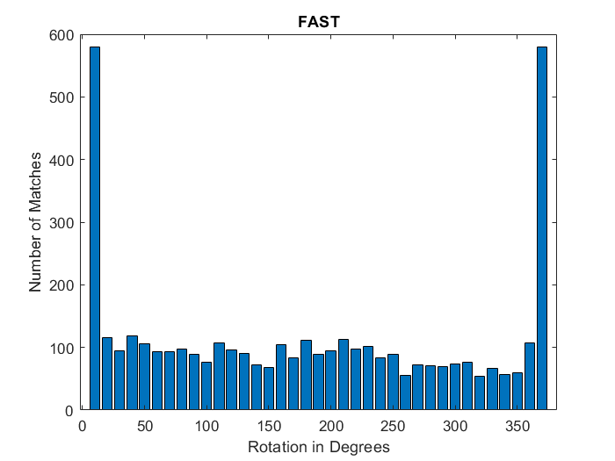

**SURF**

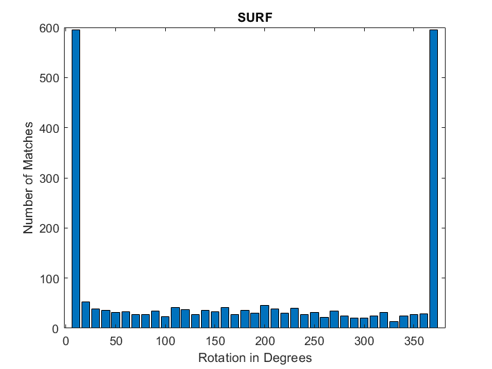

**BRIEF**

The following images are comparisons of BRIEF and SURF matches at different rotations.

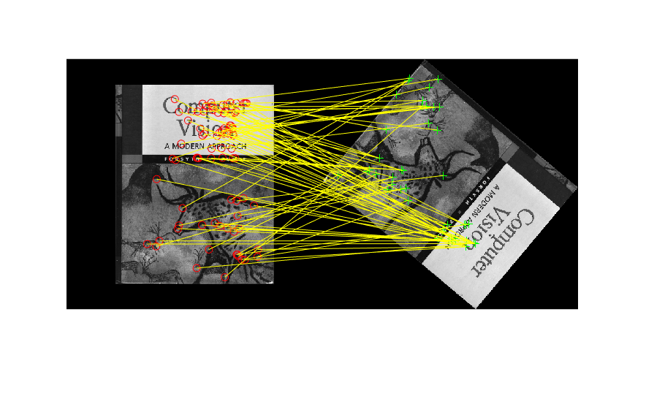

**1a - SURF**

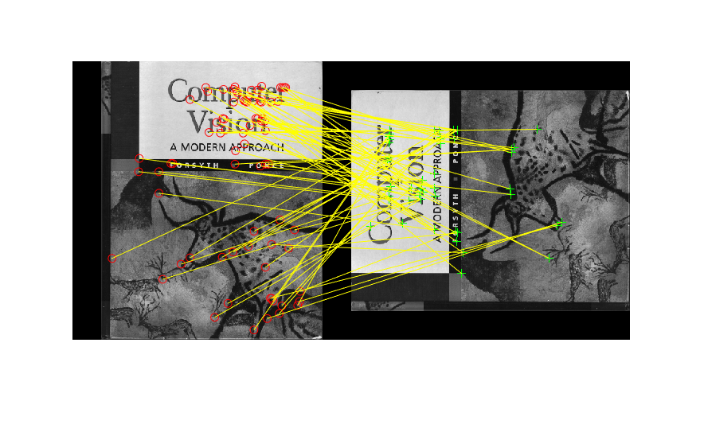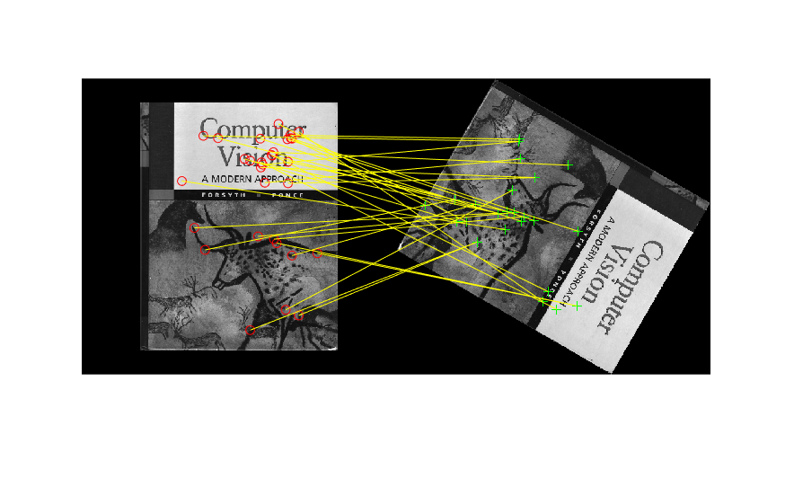

**2a - SURF**

**a**

**1b - BRIEF**

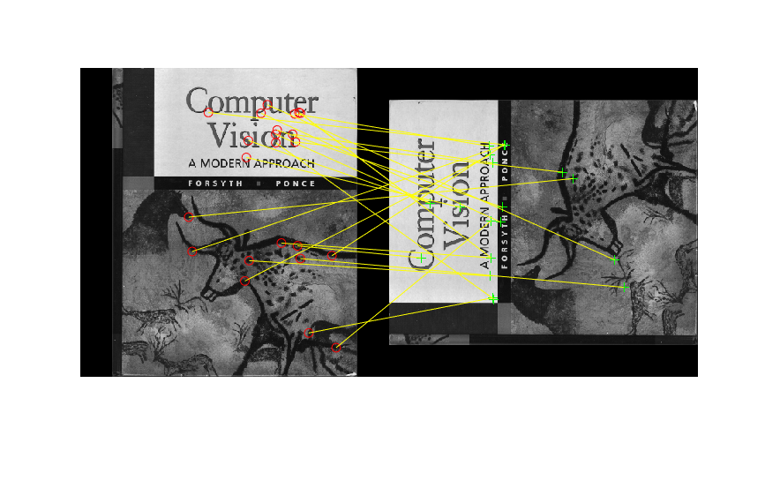

**2b - BRIEF**

**a**

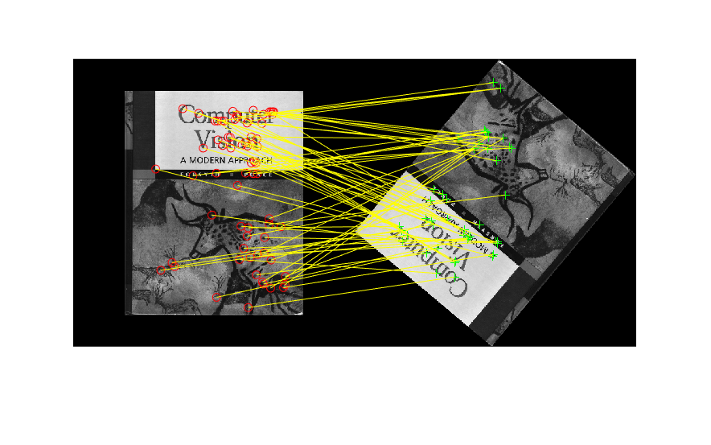

**3a - SURF**

**a**

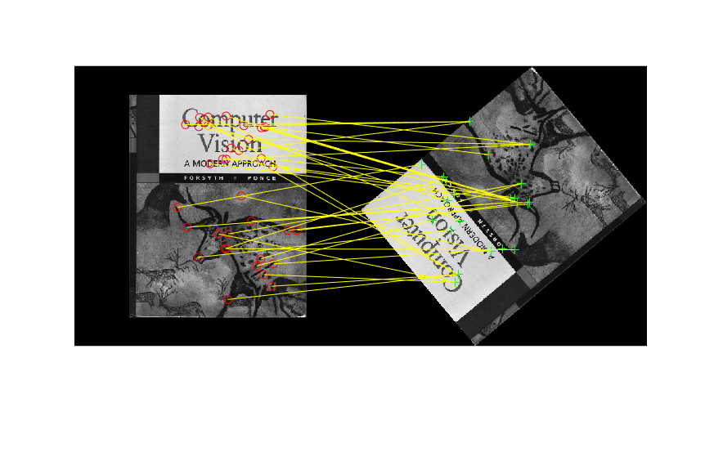

**3b- BRIEF**

**a**

Part 4.3: Homography

computeH

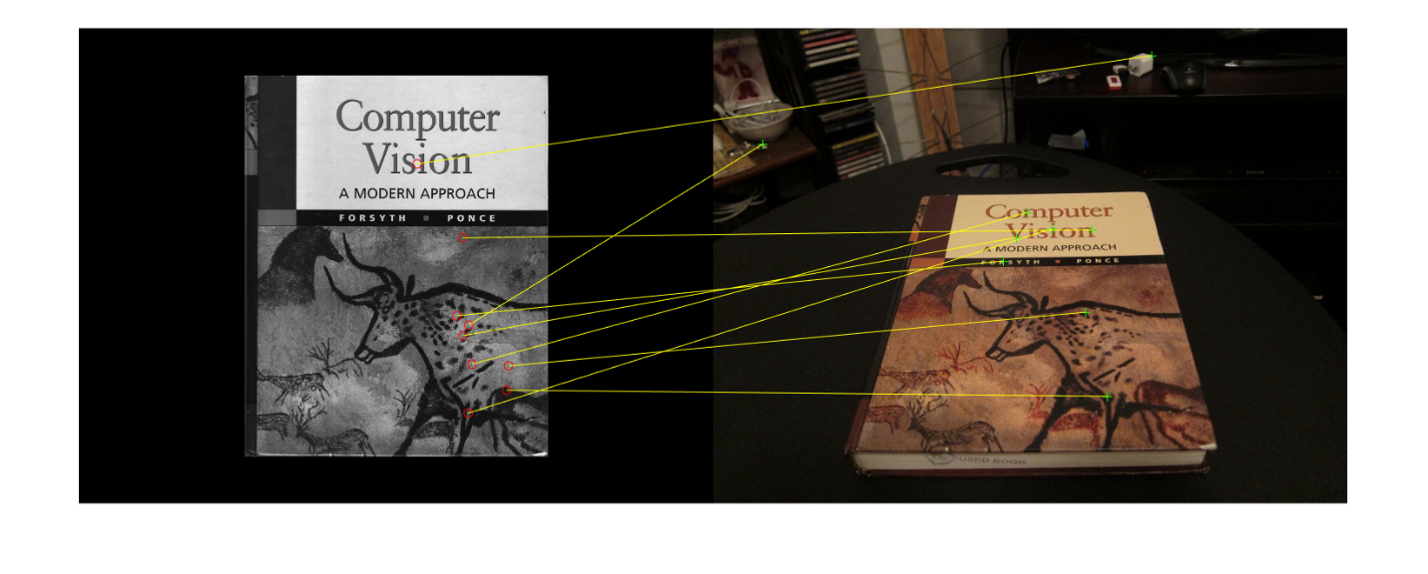

computeH_norm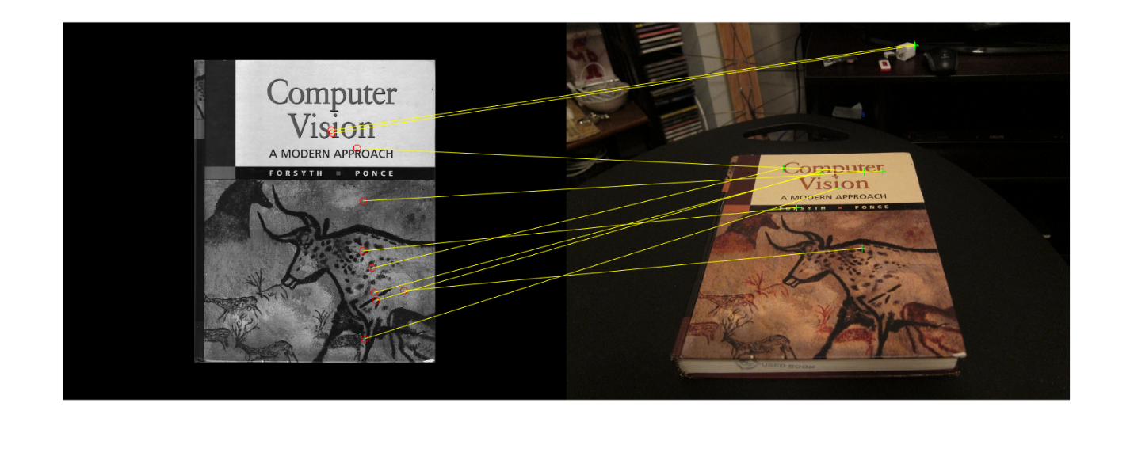

computeH_ransac

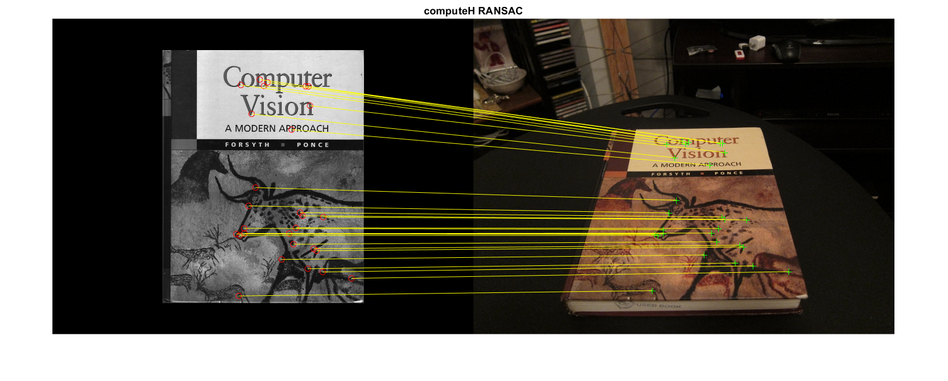

Part 4.6: HarryPotterizing a Book

